Wolny Aleksander

DESCRIPTION:

I decided to find as many bugs in the exercises as possible. Focusing only on the delineated content of the task. All tests were carried out in a manual manner. Below is a list of only errors I have found. Options that work and have been writen in the content of the task have been omitted.

WEBPAGE WITH TASKS:

<https://buggy-testingcup.pgs-soft.com/task_1>

ENVIRONMENT:

* Windows 10
* Google Chrome 71.0.3578.80 (64-bitowa)

EXERCISE 1:

* 1. Should be the upper limit on the product to 100. Since you can not add any more.



* 1. No possibility to reduce the number of products in the basket. For example, from 10 to 9. You can only delete the whole and add again, less.



* 1. There is no message like "do you really want to delete products". Protects against accidental deletion.
  2. The "Usuń" button could be in a different color, eg red. To indicate that it is used for deletion.



EXERCISE 2:

* 1. No possibility to return to all categories. When a category is selected.
  2. No Upper case support. Entering the phrase "sport" will not give a result such as entering "Sport".

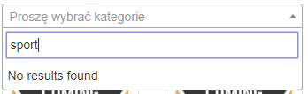 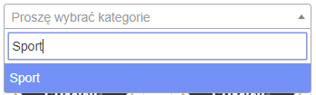

* 1. Mapping on Polish characters does not work. Entering the word "uslugi" does not suggest the word "usługi".

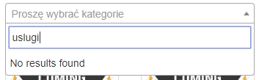 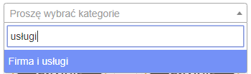

* 1. No possibility to filter the product. Typing the phrase "Piłka" does not suggest anything.

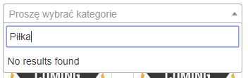

* 1. No choice of several categories from all. For example, 2 out of 3 possible.
  2. No choice of several categories from all. For example, 2 out of 3 possible.
  3. You can not enter several different products at once. E.g. "Piłka, Buty, Aparat".

EXERCISE 3:

* 1. When the form is blocked, by hovering over the input fields, the mouse changes the cursor to the blocked one. This is not the case when you hover over "Choose file" from the "Photo:" category.

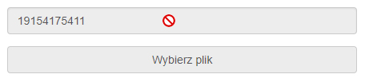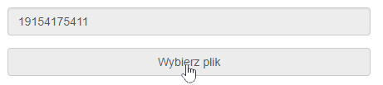

* 1. No support for the restriction of characters entered in the name and surname tab. You can enter not only letters, but also numbers and special characters.

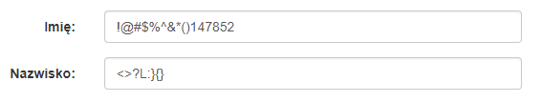

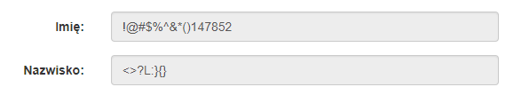

* 1. Support for restrictions on typed characters in the Phone tab for some reason allows you to enter specific special characters: „% & ( ' +”.



* 1. Ability to save an incorrect phone number.



* 1. In the Telephone tab, the placeholder should suggest what the format of the phone number should look like.
  2. No messages about successful save.
  3. The image in the "TIFF" format does not appear.
  4. No information what file format and file size are supported.
  5. The "Zapisz do pliku" option in the Menu does not work.

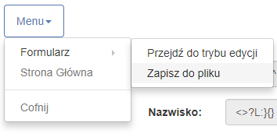

EXERCISE 4:

* 1. Lack of website responsiveness.

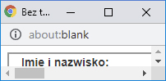

* 1. The new window has no page title.



* 1. The border around the form has a lot of empty space at the bottom.

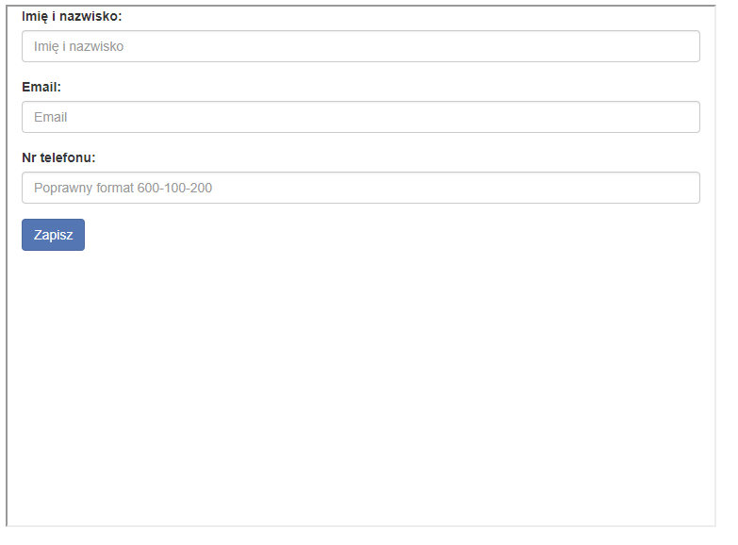

* 1. In each field, you can enter any characters.

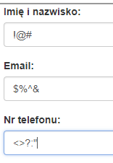

* 1. No information about the incorrectly entered format for any field.
  2. Tel No. - no limit on the number of characters entered, you can enter infinity.

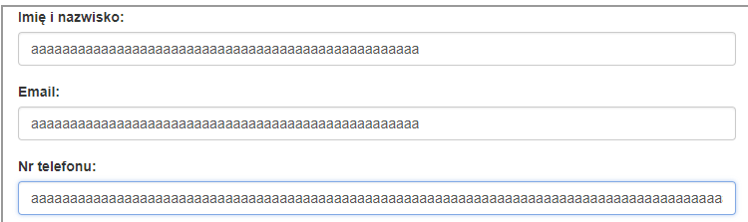

* 1. There is no "Wyślij" button, instead it is "Zapisz".



* 1. There is no information about the success of the performed action after pressing the "Zapisz" button.
  2. Placeholder email should tell you what the correct email format looks like, ex. a@b.pl.

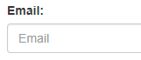

EXERCISE 5:

* 1. Wrongly named button. Should be "Browse" is "Wgraj plik".



* 1. The table displays only 10 rows, out of 20 possible.

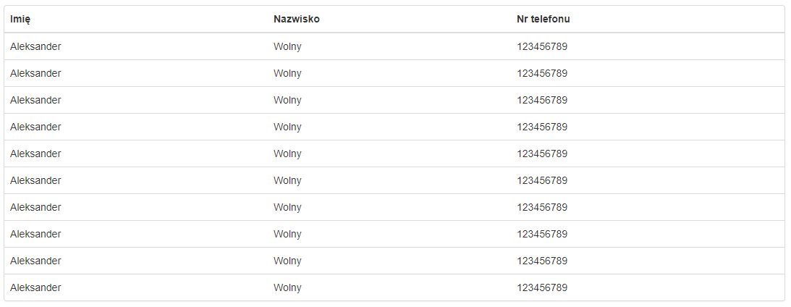

* 1. It is possible to enter no data in the first name and last name column.

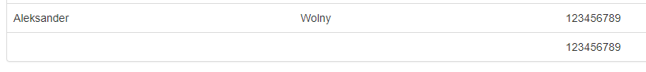

* 1. No character length restriction for name and surname.



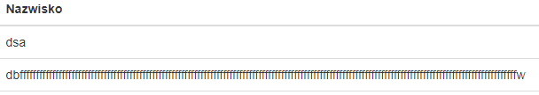

EXERCISE 6:

* 1. The "Pobierz plik" button does not work. Nothing is taken.

EXERCISE 7:

* 1. Drag & drop does not work. None of the products is added to the basket in this way.

EXERCISE 8:

* 1. No validation of the "Name and surname" field You can enter any characters, such as letters or an infinite number of letters, numbers or special characters.



EXERCISE 9:

* 1. The folder is expanded by double clicking on the folder name. The specification suggests one click.
  2. Changing the folder name to some special characters causes that the information about the folder is no longer displayed. Characters: blank character (space), „#", „%".

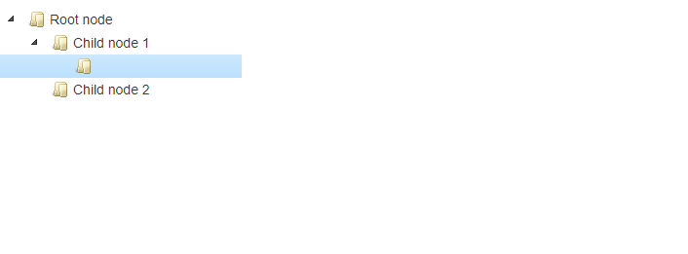

* 1. No information in the documentation - the ability to navigate through folders using only the directional arrows on the keyboard.
  2. Some special characters are displayed in the HTML Entity format. For example, the character "<" is displayed as "& lt;".

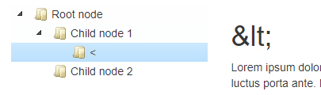

EXERCISE 10:

* 1. The js script does not work. The page is scrolled in a default way for a given browser.
  2. No "End" inscription at the bottom of the text.
  3. The text is not played. The whole works in a default way.

SUMMARY:

The site has been created so that it can be tested using automated tests. At the moment I focused on deliberate errors placed on the website and testing it in a manual way. It is very possible that in the future I will test this page in an automatic way.